20th April 2017

**YOKOHAMA’s “GEOLANDAR” to Come Factory-Equipped on New Mazda CX-5**

YOKOHAMA announced today that its “GEOLANDAR G98” tyre has been adopted as original equipment on Mazda Motor Corporation’s all-new Mazda CX-5, a crossover SUV that went on sale in Japan on 2nd February. The new Mazda CX-5 comes equipped with 225/65R17 102V size tyres.

The “GEOLANDAR G98” is part of YOKOHAMA’s GEOLANDAR line up. It was developed by applying the basic design and materials technology used in the YOKOHAMA’s BluEarth global tyre brand, which is based on the concept of “environmentally, human, and socially friendly”. The tyres enhance the vehicle’s fuel efficiency while delivering the performance expected of a luxury SUV as well as a safe, comfortable ride. They are particularly suitable for use as a summer season passenger car tyre. The tyre wall bears the “BluEarth” technology mark.

The original CX-5 features the full range of Mazda’s proprietary SKYACTIV TECHNOLOGY and KODO – Soul of Motion design. Under the slogan “an SUV all customers will enjoy,” Mazda refined every element of the SUV’s design and technology to bring a new dimension of driving pleasure to the all-new Mazda CX-5.

YOKOHAMA is aggressively developing tyres employing its leading-edge BluEarth tyre technology, and many of these tyres have been adopted by automakers as original equipment, especially on new eco cars and hybrid vehicles.

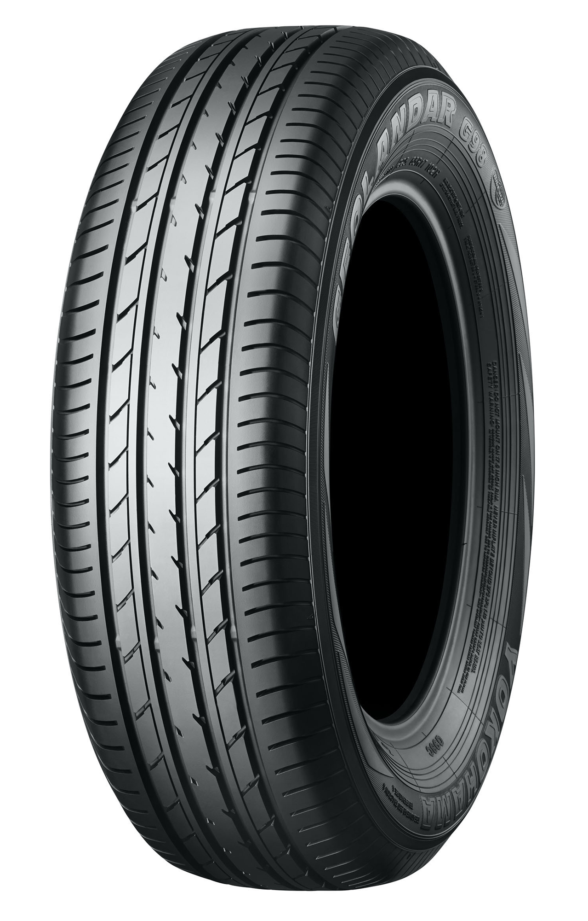

*“GEOLANDAR G98” Tire in photo differs in size from those installed on the Mazda CX-5*